**Creating a logo using macromedia freehand**

Creating a logo is the process of designing a visual emblem that succinctly represents a brand’s identity, values, and mission

While creating a logo it involves many steps like understanding the brand, coming up with the logo design and using a logo software like macromedia freehand to design the final product. Macromedia freehand is widely use logo design software that is use to design simple logo.

Here is the example of designing a simple logo**.**

**(Academia International College)**



Fig: Logo of Academia international College.

**Steps involves in making this logo**

**Step 1**: (setting up the workspace)

Launch the Freehand MX software on your computer.

Create a New Document, Go to File -> New to create a new document.

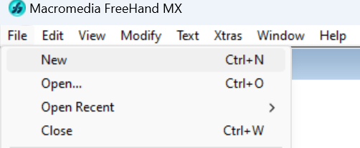

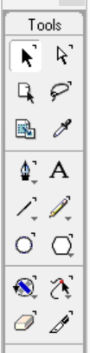**Step 2:** (Creating the Basic Shapes)

Draw the Outer Circle:

Select outer circle and click “ctrl + shift + d’ to duplicate the outer circle.

Hold ctrl + shift and resize the small circle as per your need.

**Step 3:** Creating the Hexagram (Star of David)

Draw the Triangles:

Select the Polygon Tool and set the number of sides to 3 in the properties panel.

Draw an equilateral triangle inside the inner circle.

Duplicate and rotate the triangle to form the hexagram.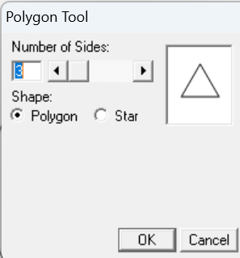

**Step 4:** (Adding the Stars)

Draw the Stars:

Select the Star Tool from the toolbar.

Click and drag to create a star shape on one side of the inner circle.

Hold the Shift key to maintain symmetry.

Duplicate the star and drag it to other side

Fill color from right side(properties bar).

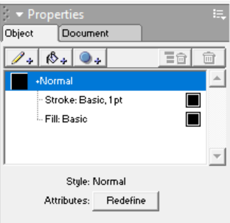

**Step 5:(**Adding text)

Duplicate the inner Circle (Ctrl + shift + D)

Select the duplicated circle and open text tab -> Attach to path.

Type name, to add address at bottom press enter and type.

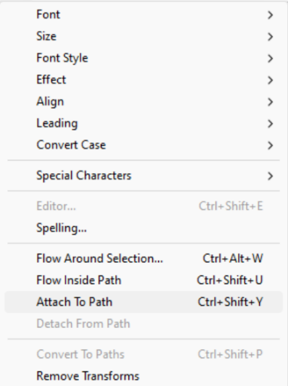

**Step 6:** (Add book)

Get the book symbol by setting the font style as Webdings and click SHIFT+7.



**Step 7:** (Saving the File)

Save the Design:

Go to File > Save As and choose a suitable file format (e.g., Freehand, EPS, or PDF) for future edits.

Also, export the logo in standard image formats like PNG or JPEG for use in various applications.

**Conclusion:**

The step-by-step approach involved setting up the workspace, crafting basic shapes, incorporating symbolic elements like stars and a hexagram, and integrating a central book icon to represent knowledge. Adding text with the college's name and location provided the final touch to ensure the logo is informative and professional.

**Creating logo using Macromedia Freehand**

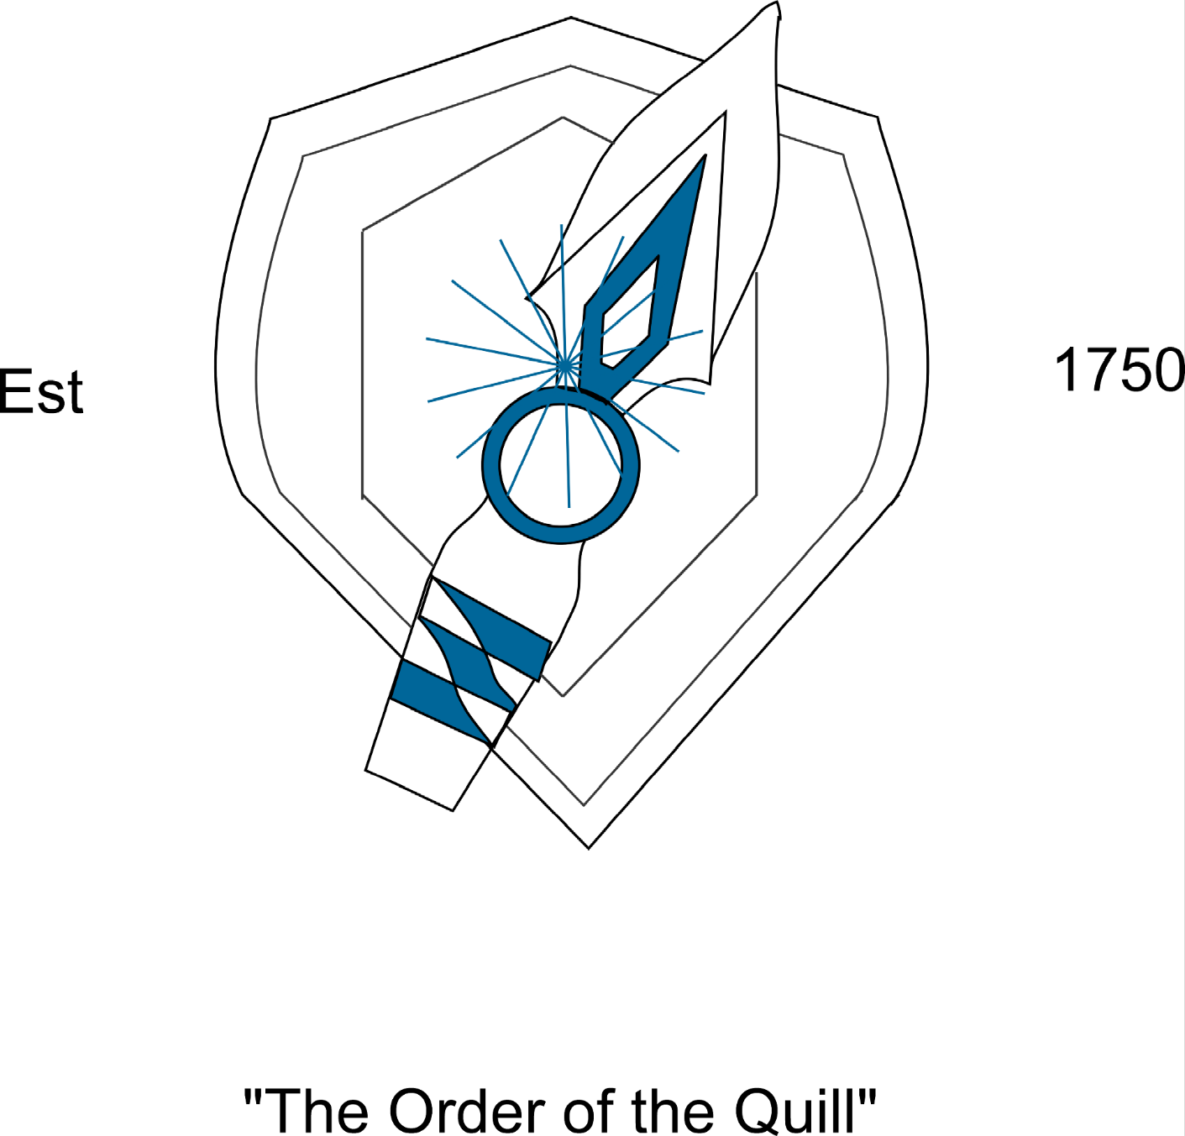

Steps to get to this design

**Step 1:** (Creating the Basic Shapes)

Draw the Outer Circle:

Select outer circle and click “ctrl + shift + d’ to duplicate the outer circle.

Hold ctrl + shift and resize the small circle as per your need.

**Step 2:** (square at the top of circle)

Using polygon tool in tool bar draw and use it to get the shape.

Duplicate and adjust the scale to get this effect.





**Step 3:** (color the image)

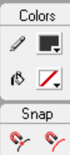Select the image and fill the color.

Using fill box option form tool box.

**Step 4:** (create one side of image)

Create one side of image using pencil, tools, line.

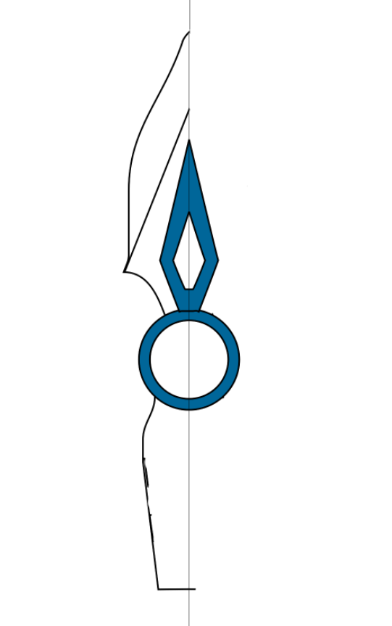

**Step 5:** (clone to other side)

After selecting which one to clone use xtra tool to clone to other side.

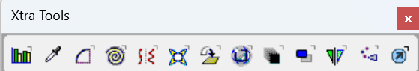



**Step 6:** (Create shield)

Using different tools and create shield.

Rotate the knife using rotate tool.

Place the knife at the center and you are done.

Use xtra opration, xtra tools, eraser and so on.

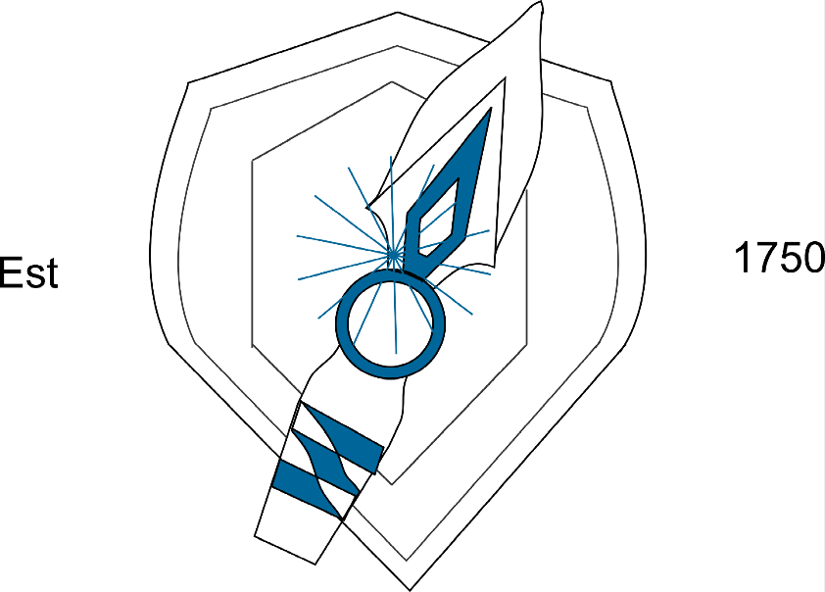

Conclusion:

There are many tools that are useful in making any kind of logo at macromedia freehand. At last, you can add some color and text there.